Level 3 Practice Programs
- Create a program to find the shortest, tallest, and mean height of players present in a football team.
Hint =>
- The formula to calculate the mean is: mean = sum of all elements/number of elements
- Create an int array named heights of size 11 and get 3 digits random height in cms for each player in the range 150 cms to 250 cms
- Write the method to Find the sum of all the elements present in the array.
- Write the method to find the mean height of the players on the football team
- Write the method to find the shortest height of the players on the football team
- Write the method to find the tallest height of the players on the football team
- Finally display the results

import java.util.Random;

public class MeanShortTall {

public static int calculateSum(int[] heights) {
int sum = 0;
for (int height : heights) {
sum += height;
}
return sum;
}

public static double calculateMean(int sum, int count) {
return (double) sum / count;
}

public static int findShortest(int[] heights) {
int shortest = heights[0];
for (int height : heights) {
if (height < shortest) {
shortest = height;
}
}
return shortest;
}

public static int findTallest(int[] heights) {
int tallest = heights[0];
for (int height : heights) {
if (height > tallest) {
tallest = height;
}
}
return tallest;
}
public static void main(String[] args) {
int[] heights = new int[11];
Random random = new Random();
for (int i = 0; i < heights.length; i++) {
heights[i] = 150 + random.nextInt(101);
}

int sum = calculateSum(heights);
double mean = calculateMean(sum, heights.length);
int shortest = findShortest(heights);
int tallest = findTallest(heights);

System.out.println("Heights: ");
for (int height : heights) {
System.out.print(height + " ");
}
System.out.println("\nSum of heights: " + sum);
System.out.println("Mean height: " + mean);
System.out.println("Shortest height: " + shortest);
System.out.println("Tallest height: " + tallest);
}

}

- Extend or Create a NumberChecker utility class and perform following task. Call from main() method the different methods and display results. Make sure all are static methods
Hint =>
- Method to Find the count of digits in the number
- Method to Store the digits of the number in a digits array
- Method to Check if a number is a duck number using the digits array. A duck number is a number that has a non-zero digit present in it
- Method to check if the number is a armstrong number using the digits array. ​​Armstrong number is a number that is equal to the sum of its own digits raised to the power of the number of digits. Eg: 153 = 1^3 + 5^3 + 3^3
- Method to find the largest and second largest elements in the digits array. Use Integer.MIN_VALUE to initialize the variable.
- Method to find the the smallest and second smallest elements in the digits array. Use Integer.MAX_VALUE to initialize the variable.

import java.util.*;

public class NumberCheckerCode {
public static int countDigits(int number) {
return String.valueOf(Math.abs(number)).length();
}

public static int[] getDigitsArray(int number) {
String numStr = String.valueOf(Math.abs(number));
int[] digits = new int[numStr.length()];
for (int i = 0; i < numStr.length(); i++) {
digits[i] = Character.getNumericValue(numStr.charAt(i));
}
return digits;
}

public static boolean isDuckNumber(int[] digits) {
for (int digit : digits) {
if (digit == 0) {
return true;
}
}
return false;
}

public static boolean isArmstrongNumber(int number, int[] digits) {
int sum = 0;
int power = digits.length;
for (int digit : digits) {
sum += Math.pow(digit, power);
}
return sum == number;
}

public static int[] findLargestTwo(int[] digits) {
int largest = Integer.MIN_VALUE;
int secondLargest = Integer.MIN_VALUE;
for (int digit : digits) {
if (digit > largest) {
secondLargest = largest;
largest = digit;
} else if (digit > secondLargest && digit != largest) {
secondLargest = digit;
}
}
return new int[]{largest, secondLargest};
}

public static int[] findSmallestTwo(int[] digits) {
int smallest = Integer.MAX_VALUE;
int secondSmallest = Integer.MAX_VALUE;
for (int digit : digits) {
if (digit < smallest) {
secondSmallest = smallest;
smallest = digit;
} else if (digit < secondSmallest && digit != smallest) {
secondSmallest = digit;
}
}
return new int[]{smallest, secondSmallest};
}
public static void main(String[] args) {
int number = 153;
System.out.println("Count of digits: " + countDigits(number));
int[] digits = getDigitsArray(number);
System.out.println("Digits array: " + java.util.Arrays.toString(digits));
System.out.println("Is Duck Number: " + isDuckNumber(digits));
System.out.println("Is Armstrong Number: " + isArmstrongNumber(number, digits));
int[] largestTwo = findLargestTwo(digits);
System.out.println("Largest: " + largestTwo[0] + ", Second Largest: " + largestTwo[1]);
int[] smallestTwo = findSmallestTwo(digits);
System.out.println("Smallest: " + smallestTwo[0] + ", Second Smallest: " + smallestTwo[1]);
}
}

- Extend or Create a NumberChecker utility class and perform following task. Call from main() method the different methods and display results. Make sure all are static methods
Hint =>
- Method to find the count of digits in the number and a Method to Store the digits of the number in a digits array
- Method to find the sum of the digits of a number using the digits array
- Method to find the sum of the squares of the digits of a number using the digits array. Use Math.pow() method
- Method to Check if a number is a harshad number using a digits array. A number is called a Harshad number if it is divisible by the sum of its digits. For e.g. 21
- Method to find the frequency of each digit in the number. Create a 2D array to store the frequency with digit in the first column and frequency in the second column.

public class NumberCheckerUtility {
public static int countDigits(int number) {
return String.valueOf(Math.abs(number)).length();
}
public static int[] getDigitsArray(int number) {
String numStr = String.valueOf(Math.abs(number));
int[] digits = new int[numStr.length()];
for (int i = 0; i < numStr.length(); i++) {
digits[i] = Character.getNumericValue(numStr.charAt(i));
}
return digits;
}
public static int sumOfArray(int[] digits) {
int sum = 0;
for (int digit : digits) {
sum += digit;
}
return sum;
}
public static int sumofsquareOfDigit(int[] digit) {
int sum=0;
for (int i = 0; i < digit.length; i++) {
sum += Math.pow(digit[i], 2);
}
return sum;
}
public static void harshadNumber(int number) {
int[] digits = getDigitsArray(number);
int sum = sumOfArray(digits);
int squareSum = sumofsquareOfDigit(digits);
if (sum * sum == squareSum) {
System.out.println(number + " is a Harshad number.");
} else {
System.out.println(number + " is not a Harshad number.");
}
}
public static int[] frequencyOfDigits(int[] digits) {
int[] frequency = new int[10];
for (int digit : digits) {
frequency[digit]++;
}
return frequency;
}
public static void main(String[] args) {
int number = 153;
System.out.println("Count of digits: " + countDigits(number));
int[] digits = getDigitsArray(number);
System.out.println("Digits array: " + java.util.Arrays.toString(digits));
System.out.println("Sum of digits: " + sumOfArray(digits));
System.out.println("Sum of squares of digits: " + sumofsquareOfDigit(digits));
harshadNumber(number);
int[] frequency = frequencyOfDigits(digits);
System.out.println("Frequency of digits: " + java.util.Arrays.toString(frequency));
}
}

- Extend or Create a NumberChecker utility class and perform following task. Call from main() method the different methods and display results. Make sure all are static methods
Hint =>
- Method to find the count of digits in the number and a Method to Store the digits of the number in a digits array
- Method to reverse the digits array
- Method to compare two arrays and check if they are equal
- Method to check if a number is a palindrome using the Digits. A palindrome number is a number that remains the same when its digits are reversed.
- Method to Check if a number is a duck number using the digits array. A duck number is a number that has a non-zero digit present in it

import java.util.*;
public class NumberCheckerUtility3 {
public static int countDigits(int number) {
return String.valueOf(Math.abs(number)).length();
}
public static int[] digitArray(int number){
int[] digits = new int[countDigits(number)];
for(int i=0;i<digits.length;i++){
digits[i] = number%10;
number = number/10;
}
return digits;
}
public static int[] reverseArray(int[] array) {
int[] reversed = new int[array.length];
for (int i = 0; i < array.length; i++) {
reversed[i] = array[array.length - 1 - i];
}
return reversed;
}
public static void equalArray(int[] array1, int[] array2) {
if (array1.length != array2.length) {
System.out.println("Arrays are not equal in length.");
return;
}
for (int i = 0; i < array1.length; i++) {
if (array1[i] != array2[i]) {
System.out.println("Arrays are not equal.");
return;
}
}
System.out.println("Arrays are equal.");
}
public static boolean isDuckNumber(int[] digits) {
for (int digit : digits) {
if (digit == 0) {
return true;
}
}
return false;
}

public static void main(String[] args) {
Scanner myObj = new Scanner(System.in);
System.out.print("Enter a number: ");
int number = myObj.nextInt();
System.out.println("Count of digits: " + countDigits(number));
int[] digits = digitArray(number);
System.out.println("Digits array: " + Arrays.toString(digits));
int[] reversedDigits = reverseArray(digits);
System.out.println("Reversed array: " + Arrays.toString(reversedDigits));
equalArray(digits, reversedDigits);
System.out.println("Is Duck Number: " + isDuckNumber(digits));
myObj.close();
}
}

- Extend or Create a NumberChecker utility class and perform following task. Call from main() method the different methods and display results. Make sure all are static methods
Hint =>
- Method to Check if a number is prime number. A prime number is a number greater than 1 that has no positive divisors other than 1 and itself.
- Method to Check if a number is a neon number. A neon number is a number where the sum of digits of the square of the number is equal to the number itself
- Method to Check if a number is a spy number. A number is called a spy number if the sum of its digits is equal to the product of its digits
- Method to Check if a number is an automorphic number. An automorphic number is a number whose square ends with the number itself. E.g. 5 is an automorphic number
- Method to Check if a number is a buzz number. A buzz number is a number that is either divisible by 7 or ends with 7

public class NumberChecker1 {
public static boolean isPrime(int number) {
if (number <= 1) return false;
for (int i = 2; i <= Math.sqrt(number); i++) {
if (number % i == 0) return false;
}
return true;
}

public static boolean isNeon(int number) {
int square = number * number;
int sum = 0;
while (square != 0) {
sum += square % 10;
square /= 10;
}
return sum == number;
}

public static boolean isSpy(int number) {
int sum = 0, product = 1;
while (number != 0) {
int digit = number % 10;
sum += digit;
product *= digit;
number /= 10;
}
return sum == product;
}

public static boolean isAutomorphic(int number) {
int square = number * number;
String numStr = Integer.toString(number);
String squareStr = Integer.toString(square);
return squareStr.endsWith(numStr);
}

public static boolean isBuzz(int number) {
return number % 7 == 0 || number % 10 == 7;
}

public static void main(String[] args) {
int number = 7;
System.out.println("Is Prime: " + isPrime(number));
System.out.println("Is Neon: " + isNeon(number));
System.out.println("Is Spy: " + isSpy(number));
System.out.println("Is Automorphic: " + isAutomorphic(number));
System.out.println("Is Buzz: " + isBuzz(number));
}
}

- Extend or Create a NumberChecker utility class and perform following task. Call from main() method the different methods and display results. Make sure all are static methods
Hint =>
- Method to find factors of a number and return them as an array. Note there are 2 for loops one for the count and another for finding the factor and storing in the array
- Method to find the greates factor of a Number using the factors array
- Method to find the sum of the factors using factors array and return the sum
- Method to find the product of the factors using factors array and return the product
- Method to find product of cube of the factors using the factors array. Use Math.pow()
- Method to Check if a number is a perfect number. Perfect numbers are positive integers that are equal to the sum of their proper divisors
- Method to find the number is a abundant number. A number is called an abundant number if the sum of its proper divisors is greater than the number itself
- Method to find the number is a deficient number. A number is called a deficient number if the sum of its proper divisors is less than the number itself
- Method to Check if a number is a strong number. A number is called a strong number if the sum of the factorial of its digits is equal to the number itself

import java.util.*;

public class NumberFactors {
public static int[] findFactors(int number) {
int count = 0;
for (int i = 1; i <= number; i++) {
if (number % i == 0) count++;
}
int[] factors = new int[count];
int index = 0;
for (int i = 1; i <= number; i++) {
if (number % i == 0) factors[index++] = i;
}
return factors;
}

public static int greatestFactor(int[] factors) {
return factors[factors.length - 2]; // excluding the number itself
}

public static int sumOfFactors(int[] factors) {
int sum = 0;
for (int f : factors) sum += f;
return sum;
}

public static int productOfFactors(int[] factors) {
int prod = 1;
for (int f : factors) prod *= f;
return prod;
}

public static double productOfCubeOfFactors(int[] factors) {
double prod = 1;
for (int f : factors) prod *= Math.pow(f, 3);
return prod;
}

public static boolean isPerfect(int number) {
int[] factors = findFactors(number);
int sum = sumOfFactors(factors) - number;
return sum == number;
}

public static boolean isAbundant(int number) {
int[] factors = findFactors(number);
int sum = sumOfFactors(factors) - number;
return sum > number;
}

public static boolean isDeficient(int number) {
int[] factors = findFactors(number);
int sum = sumOfFactors(factors) - number;
return sum < number;
}

public static boolean isStrong(int number) {
int temp = number, sum = 0;
while (temp > 0) {
int rem = temp % 10;
int fact = 1;
for (int i = 1; i <= rem; i++) fact *= i;
sum += fact;
temp /= 10;
}
return sum == number;
}

public static void main(String[] args) {
int number = 28;
int[] factors = findFactors(number);
System.out.println("Factors: " + Arrays.toString(factors));
System.out.println("Greatest Factor: " + greatestFactor(factors));
System.out.println("Sum of Factors: " + sumOfFactors(factors));
System.out.println("Product of Factors: " + productOfFactors(factors));
System.out.println("Product of Cube of Factors: " + productOfCubeOfFactors(factors));
System.out.println("Is Perfect: " + isPerfect(number));
System.out.println("Is Abundant: " + isAbundant(number));
System.out.println("Is Deficient: " + isDeficient(number));
System.out.println("Is Strong: " + isStrong(number));
}
}

- Write a program to generate a six-digit OTP number using Math.random() method. Validate the numbers are unique by generating the OTP number 10 times and ensuring all the 10 OTPs are not the same
Hint =>
- Write a method to Generate a 6-digit OTP number using Math.random()
- Create an array to save the OTP numbers generated 10 times
- Write a method to ensure that the OTP numbers generated are unique. If unique return true else return false

import java.util.*;

public class OTPgenerator {
public static int generateOTP() {
return 100000 + (int)(Math.random() * 900000);
}

public static boolean validateUniqueOTPs(int[] otps) {
Set<Integer> set = new HashSet<>();
for (int otp : otps) {
if (!set.add(otp)) return false; // duplicate found
}
return true;
}

public static void main(String[] args) {
int[] otps = new int[10];
for (int i = 0; i < otps.length; i++) {
otps[i] = generateOTP();
}

System.out.println("Generated OTPs: " + Arrays.toString(otps));
System.out.println("Are all OTPs unique? " + validateUniqueOTPs(otps));
}
}

- Create a program to display a calendar for a given month and year. The program should take the month and year as input from the user and display the calendar for that month. E.g. for 07 2005 user input, the program should display the calendar as shown below
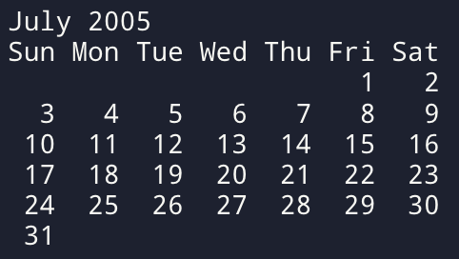
Hint =>
- Write a Method to get the name of the month. For this define a month Array to store the names of the months
- Write a Method to get the number of days in the month. For this define a days Array to store the number of days in each month. For Feb month, check for Leap Year to get the number of days. Also, define a Leap Year Method.
- Write a method to get the first day of the month using the Gregorian calendar algorithm
y0 = y − (14 − m) / 12
x = y0 + y0/4 − y0/100 + y0/400
m0 = m + 12 × ((14 − m) / 12) − 2
d0 = (d + x + 31m0 / 12) mod 7
- Displaying the Calendar requires 2 for loops.
  - The first for loop up to the first day to get the proper indentation. As in the example above 3 spaces from Sun to Thu as to be set as July 1st starts on Fri
  - The Second for loop Displays the days of the month starting from 1 to the number of days. Add proper indentation for single-digit days using %3d to display the integer right-justified in a field of width 3. Please note to move to the next line after Sat

import java.util.Scanner;

public class CalendarDisplay {
public static String getMonthName(int month) {
String[] months = {"January", "February", "March", "April", "May", "June",
"July", "August", "September", "October", "November", "December"};
return months[month - 1];
}

public static int getDaysInMonth(int month, int year) {
int[] days = {31, 28, 31, 30, 31, 30, 31, 31, 30, 31, 30, 31};
if (month == 2 && isLeapYear(year)) return 29;
return days[month - 1];
}

public static boolean isLeapYear(int year) {
return (year % 4 == 0 && year % 100 != 0) || (year % 400 == 0);
}

public static int getFirstDayOfMonth(int month, int year) {
int d = 1;
int y0 = year - (14 - month) / 12;
int x = y0 + y0/4 - y0/100 + y0/400;
int m0 = month + 12 * ((14 - month) / 12) - 2;
return (d + x + (31 * m0) / 12) % 7;
}

public static void main(String[] args) {
Scanner sc = new Scanner(System.in);
System.out.print("Enter month (1-12): ");
int month = sc.nextInt();
System.out.print("Enter year: ");
int year = sc.nextInt();

System.out.println("\n " + getMonthName(month) + " " + year);
System.out.println("Su Mo Tu We Th Fr Sa");

int spaces = getFirstDayOfMonth(month, year);
for (int i = 0; i < spaces; i++) System.out.print(" ");

int days = getDaysInMonth(month, year);
for (int day = 1; day <= days; day++) {
System.out.printf("%2d ", day);
if ((day + spaces) % 7 == 0) System.out.println();
}
sc.close();
}
}

- Write a program Euclidean distance between two points as well as the equation of the line using those two points. Use Math functions Math.pow() and Math.sqrt()
Hint =>
- Take inputs for 2 points x1, y1, and x2, y2
- Method to find the Euclidean distance between two points and return the distance
distance = (x2-x1)2 +(y2-y1)2
- Write a Method to find the equation of a line given two points and return the equation which includes the slope and the y-intercept
The equation of a line is given by the equation y = m*x + b Where m is the slope and b is the y-intercept. So firstly compute the slope using the formulae
m = (y2 - y1)/(x2 - x1)
Post that compute the y-intercept b using the formulae
b = y1 - m*x1
Finally, return an array having slope m and y-intercept b

import java.util.Scanner;

public class LineEquation {
public static double euclideanDistance(int x1, int y1, int x2, int y2) {
return Math.sqrt(Math.pow(x2 - x1, 2) + Math.pow(y2 - y1, 2));
}

public static double[] lineEquation(int x1, int y1, int x2, int y2) {
double m = (double)(y2 - y1) / (x2 - x1);
double b = y1 - m * x1;
return new double[]{m, b};
}

public static void main(String[] args) {
Scanner sc = new Scanner(System.in);
System.out.print("Enter x1, y1: ");
int x1 = sc.nextInt(), y1 = sc.nextInt();
System.out.print("Enter x2, y2: ");
int x2 = sc.nextInt(), y2 = sc.nextInt();

System.out.println("Euclidean Distance: " + euclideanDistance(x1, y1, x2, y2));
double[] line = lineEquation(x1, y1, x2, y2);
System.out.printf("Line Equation: y = %.2fx + %.2f\n", line[0], line[1]);
sc.close();
}
}

- Write a program to find the 3 points that are collinear using the slope formulae and area of triangle formulae. check A (2, 4), B (4, 6) and C (6, 8) are Collinear for sampling.
Hint =>
- Take inputs for 3 points x1, y1, x2, y2, and x3, y3
- Write a Method to find the 3 points that are collinear using the slope formula. The 3 points A(x1,y1), b(x2,y2), and c(x3,y3) are collinear if the slopes formed by 3 points ab, bc, and cd are equal.
slope AB = (y2 - y1)/(x2 - x1), slope BC = (y3 - y2)/(x3 - x3)
slope AC = (y3 - y1)/(x3 - x1) Points are collinear if
slope AB = slope BC = slope Ac
- The method to find the three points is collinear using the area of the triangle formula. The Three points are collinear if the area of the triangle formed by three points is 0. The area of a triangle is
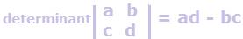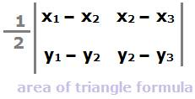
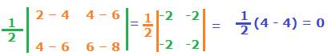
area = 0.5 * (x1 * (y2 - y3) + x2 * (y3 - y1) + x3 * (y1 - y2))

import java.util.Scanner;

public class CollinearityCheck {
public static boolean checkSlopeMethod(int x1, int y1, int x2, int y2, int x3, int y3) {
return (y2 - y1)*(x3 - x2) == (y3 - y2)*(x2 - x1);
}

public static boolean checkAreaMethod(int x1, int y1, int x2, int y2, int x3, int y3) {
double area = 0.5 * (x1*(y2 - y3) + x2*(y3 - y1) + x3*(y1 - y2));
return area == 0;
}

public static void main(String[] args) {
Scanner sc = new Scanner(System.in);
System.out.print("Enter x1, y1: ");
int x1 = sc.nextInt(), y1 = sc.nextInt();
System.out.print("Enter x2, y2: ");
int x2 = sc.nextInt(), y2 = sc.nextInt();
System.out.print("Enter x3, y3: ");
int x3 = sc.nextInt(), y3 = sc.nextInt();

System.out.println("Collinear (Slope Method): " + checkSlopeMethod(x1, y1, x2, y2, x3, y3));
System.out.println("Collinear (Area Method): " + checkAreaMethod(x1, y1, x2, y2, x3, y3));
sc.close();
}
}

- Create a program to find the bonus of 10 employees based on their years of service as well as the total bonus amount the 10-year-old company Zara has to pay as a bonus, along with the old and new salary.
Hint =>
- Zara decides to give a bonus of 5% to employees whose year of service is more than 5 years or 2% if less than 5 years
- Create a Method to determine the Salary and years of service and return the same. Use the Math.random() method to determine the 5-digit salary for each employee and also use the random method to determine the years of service. Define 2D Array to save the salary and years of service.
- Write a Method to calculate the new salary and bonus based on the logic defined above and return the new 2D Array of the latest salary and bonus amount
- Write a Method to Calculate the sum of the Old Salary, the Sum of the New Salary, and the Total Bonus Amount and display it in a Tabular Format

import java.util.Random;

public class EmployeeBonus {
public static void main(String[] args) {
int[][] employees = new int[10][2]; // [0] -> salary, [1] -> years of service
Random rand = new Random();

// Method to assign random salary and years of service
assignSalaryAndService(employees, rand);

// Method to calculate new salary and bonus
double[][] salaryBonus = calculateSalaryBonus(employees);

// Display results
displayResults(employees, salaryBonus);
}

public static void assignSalaryAndService(int[][] employees, Random rand) {
for (int i = 0; i < employees.length; i++) {
employees[i][0] = 10000 + rand.nextInt(90000); // Random 5-digit salary
employees[i][1] = 1 + rand.nextInt(15); // Random years of service (1 to 15)
}
}

public static double[][] calculateSalaryBonus(int[][] employees) {
double[][] salaryBonus = new double[employees.length][3]; // salary, bonus, new salary
for (int i = 0; i < employees.length; i++) {
double bonus = 0;
if (employees[i][1] > 5) {
bonus = 0.05 * employees[i][0]; // 5% bonus
} else {
bonus = 0.02 * employees[i][0]; // 2% bonus
}

double newSalary = employees[i][0] + bonus;
salaryBonus[i][0] = employees[i][0];
salaryBonus[i][1] = bonus;
salaryBonus[i][2] = newSalary;
}
return salaryBonus;
}

public static void displayResults(int[][] employees, double[][] salaryBonus) {
double totalOldSalary = 0, totalNewSalary = 0, totalBonus = 0;
System.out.println("Employee\tOld Salary\tYears of Service\tBonus\tNew Salary");
for (int i = 0; i < employees.length; i++) {
totalOldSalary += employees[i][0];
totalBonus += salaryBonus[i][1];
totalNewSalary += salaryBonus[i][2];
System.out.printf("%d\t\t%d\t\t%d\t\t%.2f\t%.2f\n", i + 1, employees[i][0], employees[i][1], salaryBonus[i][1], salaryBonus[i][2]);
}

System.out.printf("\nTotal Old Salary: %.2f", totalOldSalary);
System.out.printf("\nTotal New Salary: %.2f", totalNewSalary);
System.out.printf("\nTotal Bonus: %.2f", totalBonus);
}
}

- Create a program to take input marks of students in 3 subjects physics, chemistry, and maths. Compute the total, average, and the percentage score
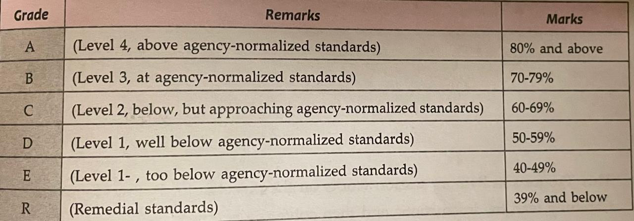
Hint =>
- Take input for the number of students
- Write a method to generate random 2-digit scores for Physics, Chemistry, and Math (PCM) for the students and return the scores. This method returns a 2D array with PCM scores for all students
- Write a Method to calculate the total, average, and percentages for each student and return a 2D array with the corresponding values. Please ensure to round off the values to 2 Digits using the Math.round() method.
- Finally, write a Method to display the scorecard of all students with their scores, total, average, and percentage in a tabular format using "\t".
import java.util.Random;
import java.util.Scanner;

public class StudentScores {
public static void main(String[] args) {
Scanner sc = new Scanner(System.in);

// Input number of students
System.out.print("Enter the number of students: ");
int numStudents = sc.nextInt();

// Generate random marks for students
int[][] marks = generateRandomMarks(numStudents);

// Calculate total, average, and percentage
double[][] scores = calculateScores(marks);

// Display scorecard
displayScorecard(scores, numStudents);
}

public static int[][] generateRandomMarks(int numStudents) {
Random rand = new Random();
int[][] marks = new int[numStudents][3]; // 3 subjects (PCM)

for (int i = 0; i < numStudents; i++) {
for (int j = 0; j < 3; j++) {
marks[i][j] = rand.nextInt(100) + 1; // Random marks between 1 and 100
}
}
return marks;
}

public static double[][] calculateScores(int[][] marks) {
double[][] scores = new double[marks.length][4]; // Total, Average, Percentage

for (int i = 0; i < marks.length; i++) {
double total = 0;
for (int j = 0; j < 3; j++) {
total += marks[i][j];
}
double average = total / 3;
double percentage = (total / 300) * 100;

scores[i][0] = total;
scores[i][1] = average;
scores[i][2] = percentage;
}
return scores;
}

public static void displayScorecard(double[][] scores, int numStudents) {
System.out.println("Student\tPhysics\tChemistry\tMaths\tTotal\tAverage\tPercentage");
for (int i = 0; i < numStudents; i++) {
System.out.printf("%d\t", i + 1);
for (int j = 0; j < 3; j++) {
System.out.printf("%d\t\t", scores[i][j]);
}
System.out.printf("%.2f\t%.2f\t%.2f\n", scores[i][0], scores[i][1], scores[i][2]);
}
}
}

- Write a program to perform matrix manipulation operations like addition, subtraction, multiplication, and transpose. Also finding the determinant and inverse of a matrix. The program should take random matrices as input and display the result of the operations.
Hint =>
- Write a Method to create a random matrix taking rows and columns as parameters
- Write a Method to add two matrices
- Write a Method to subtract two matrices
- Write a Method to multiply two matrices
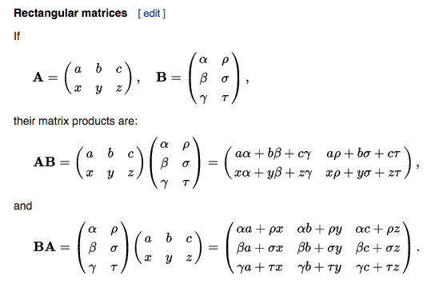
- Write a Method to find the transpose of a matrix
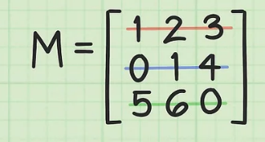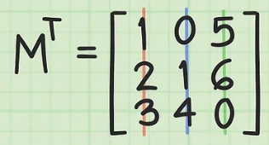
- Write a Method to find the determinant of a 2x2 matrix
- Write a Method to find the determinant of a 3x3 matrix
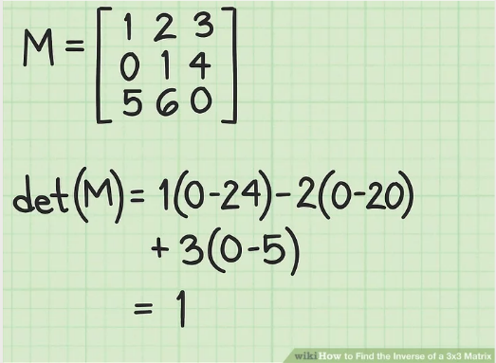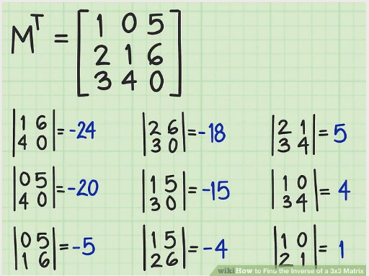
- Write a Method to find the inverse of a 2x2 matrix
- Write a Method to find the inverse of a 3x3 matrix
- Write a Method to display a matrix

import java.util.Random;

public class MatrixOperations {
public static void main(String[] args) {
int rows = 3, cols = 3;
int[][] matrix1 = generateRandomMatrix(rows, cols);
int[][] matrix2 = generateRandomMatrix(rows, cols);

displayMatrix(matrix1);
displayMatrix(matrix2);

int[][] addedMatrix = addMatrices(matrix1, matrix2);
System.out.println("Matrix Addition:");
displayMatrix(addedMatrix);

int[][] multipliedMatrix = multiplyMatrices(matrix1, matrix2);
System.out.println("Matrix Multiplication:");
displayMatrix(multipliedMatrix);

int[][] transposedMatrix = transposeMatrix(matrix1);
System.out.println("Matrix Transpose:");
displayMatrix(transposedMatrix);

// Determinants
System.out.println("Determinant of 2x2 Matrix: " + determinant2x2(matrix1));
System.out.println("Determinant of 3x3 Matrix: " + determinant3x3(matrix1));
}

public static int[][] generateRandomMatrix(int rows, int cols) {
Random rand = new Random();
int[][] matrix = new int[rows][cols];
for (int i = 0; i < rows; i++) {
for (int j = 0; j < cols; j++) {
matrix[i][j] = rand.nextInt(10) + 1; // Random numbers 1-10
}
}
return matrix;
}

public static int[][] addMatrices(int[][] m1, int[][] m2) {
int rows = m1.length;
int cols = m1[0].length;
int[][] result = new int[rows][cols];

for (int i = 0; i < rows; i++) {
for (int j = 0; j < cols; j++) {
result[i][j] = m1[i][j] + m2[i][j];
}
}
return result;
}

public static int[][] multiplyMatrices(int[][] m1, int[][] m2) {
int rows = m1.length;
int cols = m2[0].length;
int[][] result = new int[rows][cols];

for (int i = 0; i < rows; i++) {
for (int j = 0; j < cols; j++) {
for (int k = 0; k < m1[0].length; k++) {
result[i][j] += m1[i][k] * m2[k][j];
}
}
}
return result;
}

public static int[][] transposeMatrix(int[][] matrix) {
int rows = matrix.length;
int cols = matrix[0].length;
int[][] result = new int[cols][rows];

for (int i = 0; i < rows; i++) {
for (int j = 0; j < cols; j++) {
result[j][i] = matrix[i][j];
}
}
return result;
}

public static int determinant2x2(int[][] matrix) {
return matrix[0][0] * matrix[1][1] - matrix[0][1] * matrix[1][0];
}

public static int determinant3x3(int[][] matrix) {
return matrix[0][0] * (matrix[1][1] * matrix[2][2] - matrix[1][2] * matrix[2][1]) -
matrix[0][1] * (matrix[1][0] * matrix[2][2] - matrix[1][2] * matrix[2][0]) +
matrix[0][2] * (matrix[1][0] * matrix[2][1] - matrix[1][1] * matrix[2][0]);
}

public static void displayMatrix(int[][] matrix) {
for (int i = 0; i < matrix.length; i++) {
for (int j = 0; j < matrix[i].length; j++) {
System.out.print(matrix[i][j] + "\t");
}
System.out.println();
}
}
}

